10. Tuning of autoISF settings for Full Closed Loop aided by the Emulator V.2.5 for 301

Please note that with autoISF you are in an early-dev. environment, where the user interface is not optimized for safety of users who stray away from intended ways to use. Good safety features exist, but these are only as good as the development-oriented user understands and implements them. This is not a medical product, refer to disclaimer in section 0

Available related case studies:

Case study 10.1:

Based on older autoISF and older Emulator versions, examples from emulator use can be found in case study 6.2, in case study 4.1 (last pages there), and case study 8.2
10.1 Installing the Emulator on your PC
10.2 Analyzing loop decisions in logfiles
10.3 What-if analysis

You can set up and tune the system for full closed loop as described in previous sections. Doing this by frequently analyzing screenshots that must be taken in real-time of the AAPS SMB tab is tedious, however.

More elegant and precise tuning can be done with a special evaluation software for the AAPS logfiles, by using the Emulator.

In the Emulator, you can see in tabular and graphical form, which autoISF component contributed to SMB values that determined the glucose curve.

Note that iOS based variants of autoISF (in iAPS or Open iAPS) can not use the Emulator. Refer to section 11.3.

10.1 Installation of the emulator on your PC

10.1.1 First dowenload QPython3L onto your PC. Then download from: https://github.com/ga-zelle/APS-what-if/blob/A3.2.0.4_ai3.0.1_dev/software :
each of these 5 py resp. config. files. To do this, you must press, for each one, here e : : ……………………………..
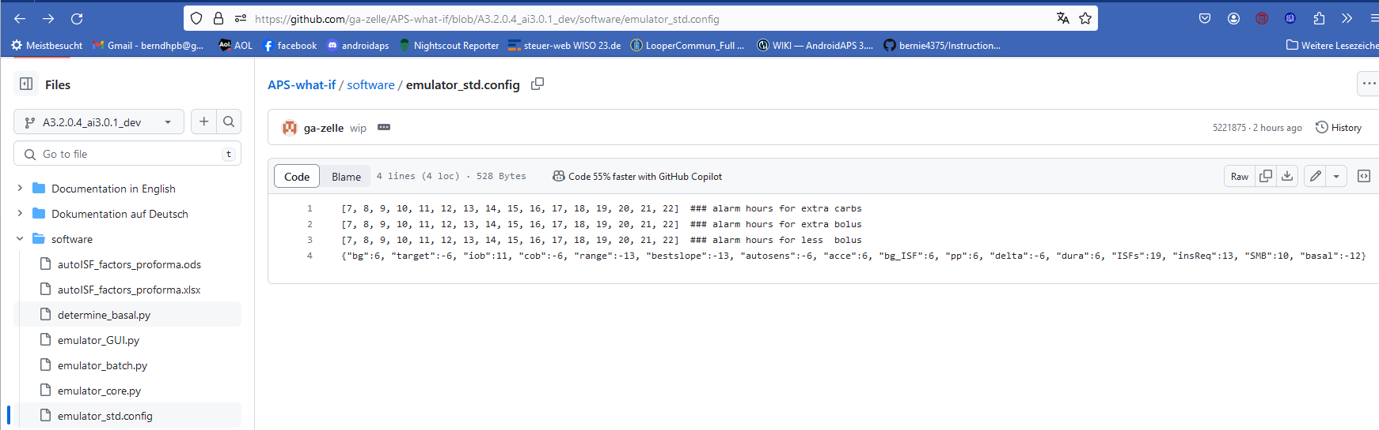

    - Retrieve these 5 downloaded files on your PC (list of recent downloads), and shift them into a folder in which, or neighboring to which, you also keep your AAPS logfiles. (These you must copy about once a week from your phone )
    - One of these 5 files is “emulator_GUI.py“. Create a link to it, and drag that link onto your desktop. Name it something like Emulator start.

    - Repeat steps 10.1.1. and step 10.1.2. for 2 more py files from https://github.com/ga-zelle/Scan-APS-logfiles/blob/main and download also these:
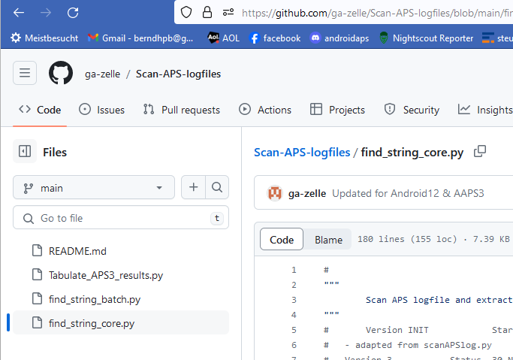
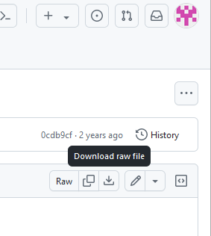

  - Read and analyze logfiles with help from the emulator
10.2.1 Set up a “no change” (empty) vdf file (Note: for what-if analysis, more entries will be made in vdf later, see section 3)
To do this, just open Notepad++ (from list of all programs on your PC). Store that in a file of your current emulator project you are about to start (see my storage path in top line here)
The no change .vdf should look like something like this:
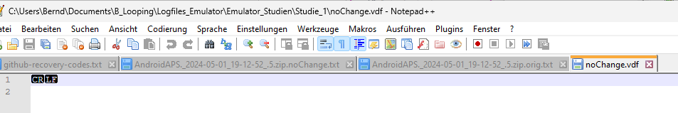
Erase any entries after CR LF and also in lines 2 ff, if any

10.2.2 Make sure you have the AAPS logfiles you might want to analyze in a immediate neighboring file to your project file (as example given headline shown in 2.1)

10.2.3 Now go to your PC desktop, and start the emulator by just pressing the button you installed in step 10.1.3
This opens a big dialogue box with 3 fields that you must fill in with the applicable path (without any quotation marks “..”) from your explorer (file system):
- The top box marks the path to your current emulator project (where you want to store results)
- The middle box marks the path to your current vdf (what kind of analysis; here: read-only; se section 3 for what-if)
- The third box marks the path to your AAPS logfiles you wish to look into

(screen)

At the bottom, you get the opportunity to limit the analysis to specified days, and times of day, within these logfiles

10.2.4 Press “Run emulation”.
This produces sometimes an error message (in which case you must seek help, in the Github materials provided by ga-zelle, or in Discord/Full-Closed-Looping/emulate-aaps here: https://discord.gg/n3tD5eXExC

What should come up is results, which you can look into in a couple of ways.

10.2.4.1 Tabular presentation of how parameters like bg, iob, iobTH, the various ISF contributors, bg target and insulinRequired etc. develop every 5 minutes, and what SMB size and %TBR resulted.

      - Best copy the entire table into a new Excel sheet where you can :

* add right next to the standard world time your time zone’s time. For instance, adding +2/24 translates the UTZ column into central European winter time column next to it (where currently a row of Z stands). Likewise, in summer (?), substract like -5/24 from UTZ for an US East Coast time scale. Highlight all time fields and switch from hh:mm:ss format to hh:mm

* hide any column you find less important to look at for your intended analysis

* hide lines (time segments) you find less important to look at for your intended analysis
Recommendation is to hide, not erase, so you can easy pull up more again, and also “boxes” (data fields) retain their original position in both tables

Usually you will color mark where relevant SMBs were given, which of the ISFs (and underlying weights) was strongly contributing (note that this can be good or not good) . Also where iobTH was exceeded, whether an Automation kicked in e.g. setting a TT, when there were periods with zero insulinRequired.

You may be able to formulate a hypothesis or two, what settings (…ISF_weights, iobTH%, SMB_range_extention, autoISFmax …) should be changed for improvement (then go to 10.3)
      - Text of all SMB tab info

Where, example

Search options (see case study ….)

      - Last graph
Example

  - Do what-if analysis using the emulator

In the following you see an example how you can analyze a day of logfiles, and selecting the time span of interest, for instance 11-24 h to look at how autoISF managed lunch and dinner.

You have to go through the emulator twice, one time loading the no change.vdf, and then start over with the emulator with the (desired changes).vdf.

10.3.1 Define your investigated changes in a (your changes).vdf

blabla + screen to follow

10.3.2 Run the emulator with (your changes).vdf

A run with just noChange.vdf was already presented in section 10.2.
Make sure you put the results from this “no change” run into the same file (in the example given below, “Studie 3”, see the 1st input line of the emulator main screen).

The second run is done the same way, but the (your changes).vdf must be loaded into the 2nd input field, where formerly you had the no change.vdf.:

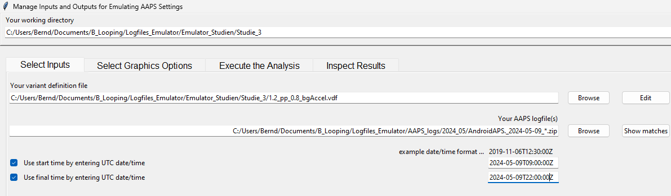
In the 3rd input field, give the path to your stored logfiles. A good way to do this is:
- Browse in your Windows Explorer to any logfile from the desired day (2024-05-09 in above example)
- Replace the time with an asterix * (this means you look at all-day data, in UTZ time). Check whether this will work by pressing Show matches . You should see all logfiles from that day in a pop-up info box.
- As I wanted to look at 11 am –midnight for lunch and dinner related data, I :
  - clicked the bottom left two boxes
  - copied the date 2024-05-09 over the default date in the bottom right two data fields
  - after T (for time), I entered the desired time of analysis AFTER conversion into my local time (Central EU summer time minus 2 hours = UTZ; so to look at 11 to midnight of my AAPS screen, I must enter here 09.00:00Z, and below it 22:00:00Z).
After making these entries, press Execute the Analysis, (evtl also Clear old Data) and Run Emulation

10.3.3 Emulation results

All results from your (your changes).vdf emulator run now automatically went where the noChange.vdf results are already stored, see example of the “Studie 3” file, below:

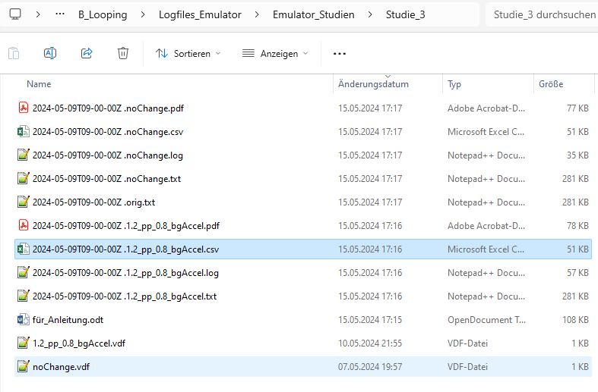
The noChange.log has all the info your series of SMB tabs had that day.
How to search in this vast list is shown elsewhere (see ).
Likewise, the (your changes).log gives for each loop decision in all detail how and why that decision would have changed with the different parameter inputs you are checking out here (In the example, it was a check on the difference a 20% stronger pp_weight and 20% weaker bgAccel_weight would make.) Note that:
- Any relevant change would put your bg curve on a different trajectory, so it would influence also all following results. Therefore, what you get here is not a complete modelling how your bg would have developed in the alternative scenario. But you can investigate in which stages the parameter(s) you are looking at in your current “what-if” had big influence, and in which direction the changes would go.
- A good way to employ the what-if analysis is real time, on your smartphone, using speech synthesis (see section 1): Then you get real-time info, as to exactly when a significantly different proposal would emerge, and can decide (and watch!) real-time whether to follow the new idea and not was probably better.
- Observe that a setting change must work well for you not just in one point of time for one kind of meal, but you must look at all time slots in the investigated meal, plus analyze with the same tool a totally different meal within your usual spectrum, how things work out there
The noChange.csv table gives all relevant data. Besides development of bg and iob you see the calculated insulinRequired in each loop decision, and how each of the autoISF categories contributed to the decision (notably regarding SMB size).
The (your changes).csv shows in detail how every single loop decision would be influenced by the different settings you are investigating. To inspect that huge table, click on the Z behind the start UTC time entry (see black box in the Z column of the following table
If you like to see the bg in each screen, too, go 3 or 4 columns farther to the right with your black box
Then, go to window/fix. Now you can scroll through the data and always see headline and time (or time and bg level).
To further ease analysis, feel free to temporarily erase (hide) any columns that you (think you) do not need for the intended analysis.
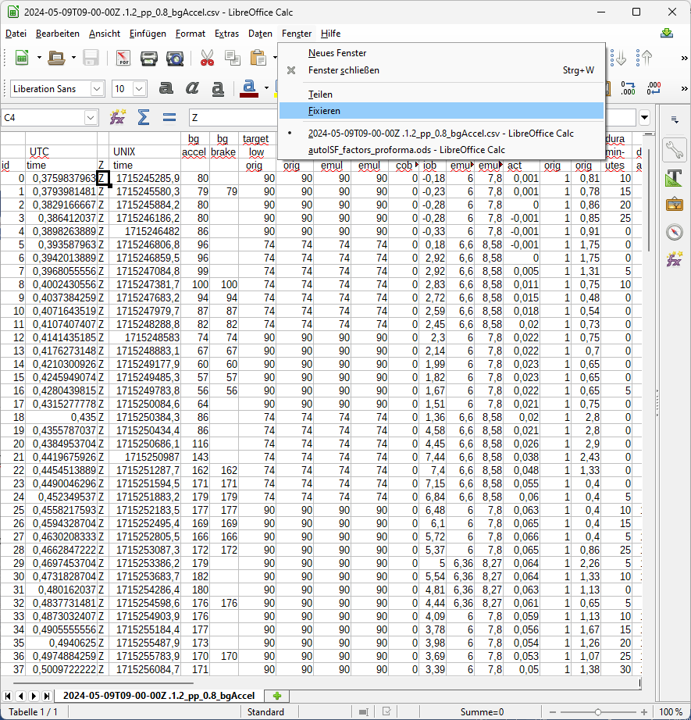
Still, the csv tables are overwhelming. You could proceed in either of two directions now:
- Convert both csv files into Excel or into Libre office calculator, and combine them into one table. Hide columns (and eventually also lines) that are of no particular interest for your analysis. Mark effects with color, add extra columns with additional calculations …

- For the core data relevant to tuning of your autoISF settings, autoISF_factors_proforma.ods is provided as an extra tool that you download from here:
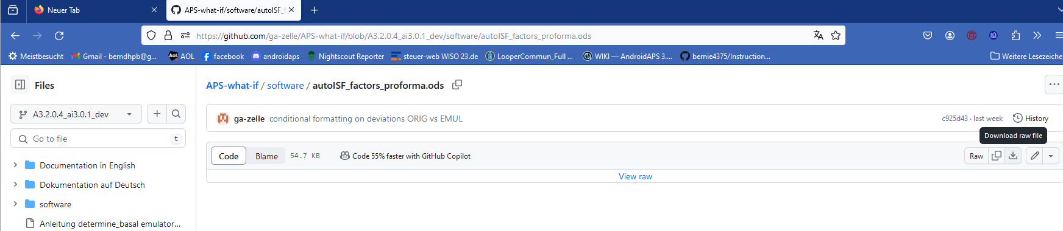
Put that file into your one level above the single files for all your studies:
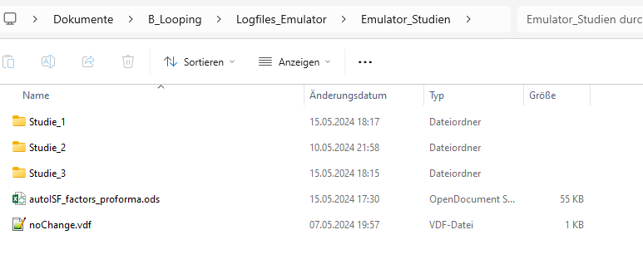
Now, if we want to use this tool on the two csv files of our Studie_3 file, we must proceed as follows (for each of the two .csv files, separately):
- Click on the .csv file and open in Libre office calculator.
- Make sure the time column is set to US_English:
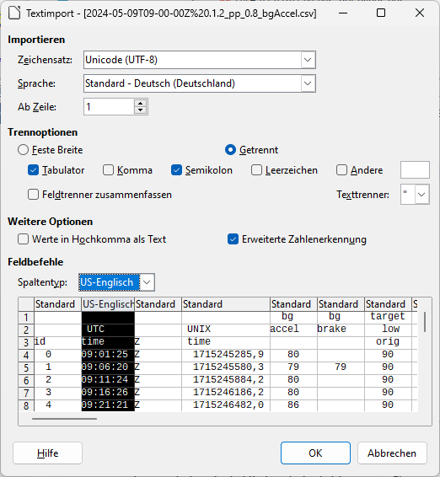

- Now start, in Libre office calculator, the autoISF_factors_proforma.ods …
This turns the first 30-some lines of your csv table (left side) into a form in which important effects are highlighted in color, and formatting is improved:
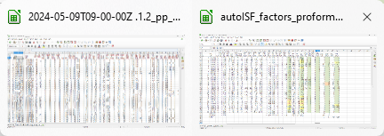

Now, you want this for the entire table.
In the autoISF_factors_proforma table, highlight 20 or more lines (not including the first or last), and mouse right hand/insert above … 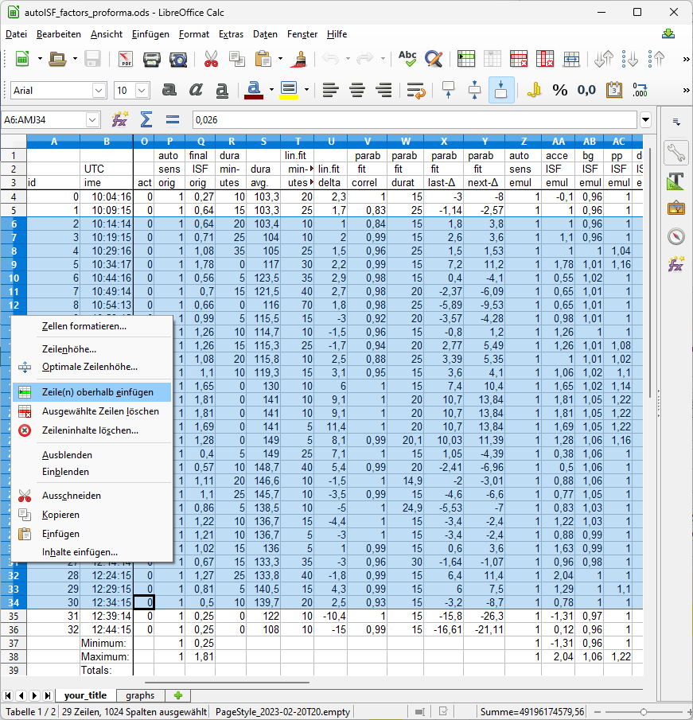

Do this as often as you need to create the number of lines that your emulated csv file comes with.
If you ended up with too many lines, erase the superfluous number (any four, in the example):
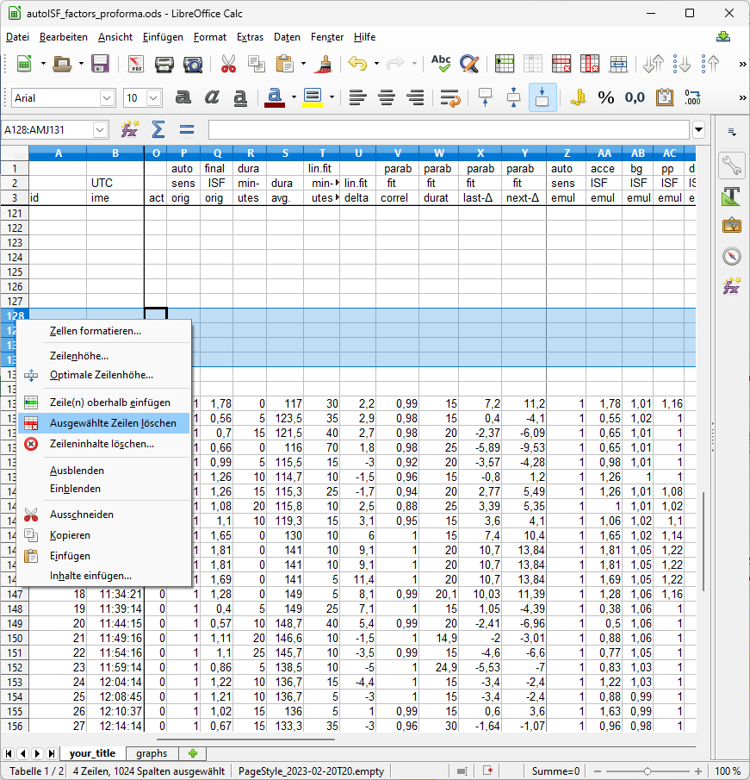
Then just copy it in, by selecting all data lines in the emulated csv, and pasting (paste special, values only) into box A4 of your “elonged” autoISF_factors_performa.ods.
The bottom tab “your_title” should be re-named by you, best with day of log you analyze, and your what-if parameters (so, the name of your csv file could be put in here)
Now you have a table with optimized lay-out that incorporates key data from both your no change AND of your investigated changes.csv files.
A super neat extra feature is already pre-programmed, which you can see if you click on the bottom tab “graphs”.
The top graph is the bg curve (the actually seen bg).
Note that for the what-if no bg development over the time range is available. (The noChange one is also given there).
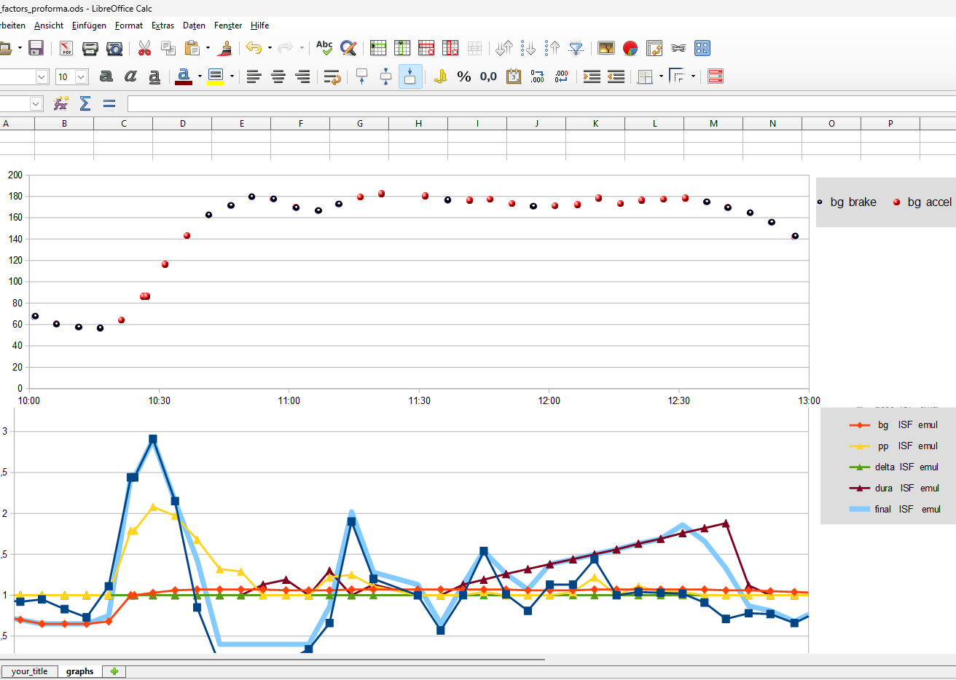
The bottom graph (do one for each, the noChange or the (yourChanges) case) shows the amplification factors coming from each autoISF category, and the overall resulting ISF amplication.
You probably have to widen the time scale (double click on the time axis, and type the desired time span (min and max UTC)(and spacing of data points, 00:30:00 or 00:15:00) into this box:
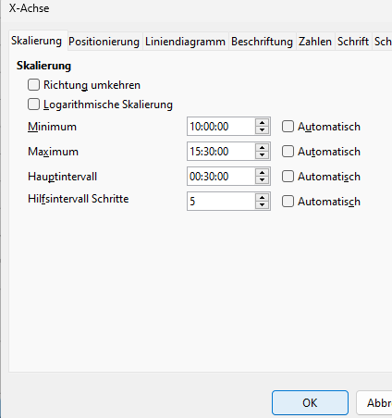
In the given example above, the 2.5 hours were not enough yet to analyze this 10:30 UTC (12:30 AAPS) lunch; we need to look until bg is near target (hopefully before dinner starts).

FCL users should first look at the initial bg rise in the noChangechart, and see how bgAccel_ISF and pp_ISF acted, or could have acted in improved ways.
The see whether yourChange idea could have contributed, or you better think of a new one.
It is very important to do such analysis for two or three very different meal that you wish the algo to automatically handle. See section 4.2/4.3 on how meals with very different carb loads might benefit or also suffer from too aggressive or to mild (category)_ISF_weights you could set.
The initial iob received might be limited by allowed SMB sizes, autoISFmax, or the (dynamic!) iobTH. You will have to look into the data table to find out about this (a quick orientation is also possible in the pdf result files you have in your project ( ) file.
Only once you found OK weights for bgAccel- and pp_ISF_weights, does it make sense to go tune the dura_ISF_weight. 12:00 – 12:45 UTC in above graph, the resulting effective ISF is dominated by dura_ISF. Just judging from the picture, a stronger weight might be worth trying. However, we really need to see the insulinRequired calculation and the further development because impatience about bringing bg values down faster too often results in hypoglycemia later.

The noChange.pdf is a chart that shows along the time axis (down), from right to left:
- Red: the bg curve
- Yellow: the bg target (note that I do no manual “EatingSoonTT” but for bg rises over +10 mg/dl I have an Automation that sets low TT for a couple of minutes)
- Light blue corridor: Left edge is set iobTH, and bandwidth +30% (would be +20% at elevated TT)
- Dark blue line: iob (exceeding twice the iobTH, with temp. SMB shut-off
As bg did not convincingly come down enough, one could hypothesize that iobTH should be elevated. ((But, again, this would have to be confirmed also with other kinds of meals)).
- Thin yellow line: Insulin activity
- Green dotted line: ISF as would result from AAPS w/Autosens
- Green scatter points: autoISF ISF no Chage (lighter points) or what-if (darker points)
- Black line: Profile ISF
- Gray scatter points: ISF weakened (to the left of black line) or strengthened (to the right)
- Orange line: cob=0 at all times (in FCL)
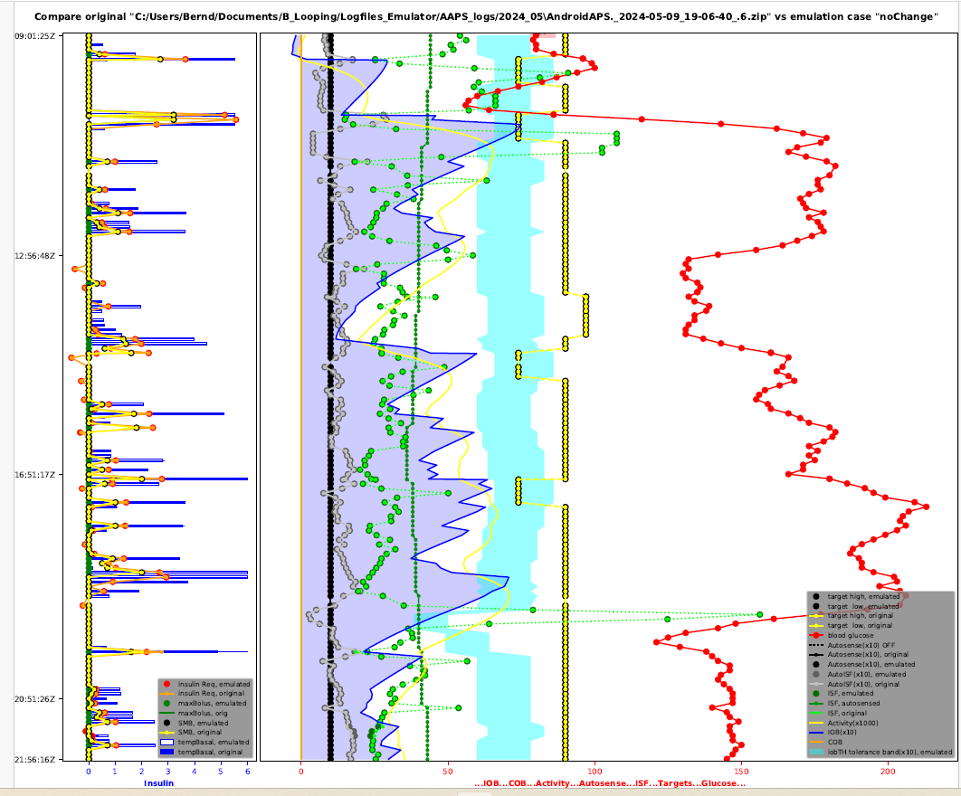
Chart with blue peaks on the left side:
(to be explained later)

